SEVERN BRIDGE

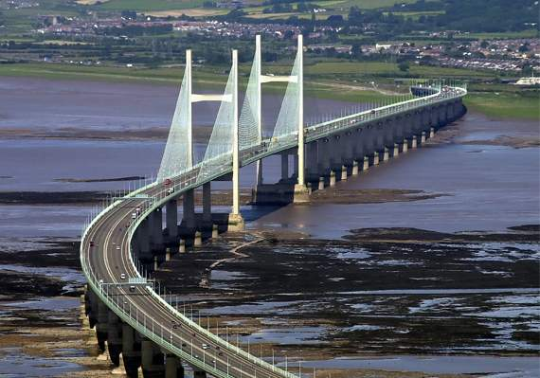Top of Form

The Severn Bridge is a remarkable engineering achievement that spans the estuary of the River Severn, linking the counties of South Gloucestershire in England and Monmouthshire in Wales. It consists of two major crossings: the original Severn Bridge and the newer Second Severn Crossing, collectively forming a vital transportation artery connecting southwest England with south Wales.

The original Severn Bridge, inaugurated in 1966, stands as an iconic symbol of cross-border connectivity. Its elegant suspension design spans approximately 988 meters (3,241 feet), with a main span of 988 meters (3,241 feet). At the time of its completion, it was the longest span of any bridge in the United Kingdom. The Second Severn Crossing, completed in 1996, complements the original bridge, offering additional capacity to accommodate the region's growing traffic demands.

The construction of the Severn Bridge was a monumental undertaking, requiring innovative engineering solutions to overcome the challenges posed by the estuary's strong tidal currents, variable weather conditions, and the need to maintain navigation channels for maritime traffic. Engineers employed state-of-the-art techniques to design and build the bridge, including prefabricated components and advanced materials, ensuring its durability and longevity. British engineering on a global scale.